Track 58 (Noni): C2009,3,58

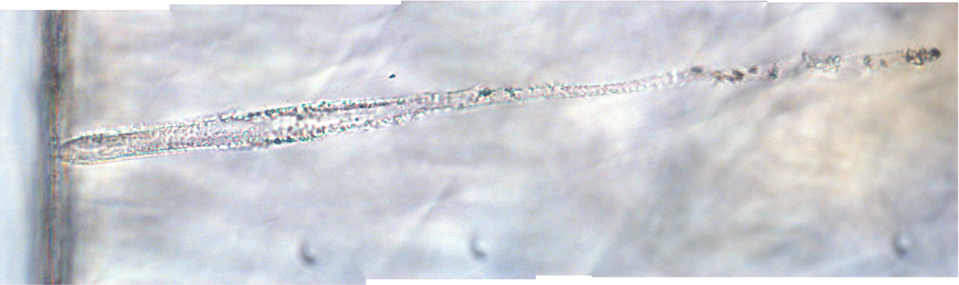

Type: A
Length: 0.29 mm

Sample type: microtomed slices embedded in acrylic
Analysis method: TEM
State of samples: variable surface carbon contamination from electron beam, possible damage to internal crystalline structures

Mineralogy and apparent grain sizes

Terminal particle (< 5 um) – Fragment 1

Core of Fe oxides and Ni oxides with surrounding shell of submicron ~Fo90-95, Mg+Al silicate glass and kosmochloric diopside. Electron DPs consistent with olivine and diopside atomic structures.

Other minor/trace minerals observed:

None

